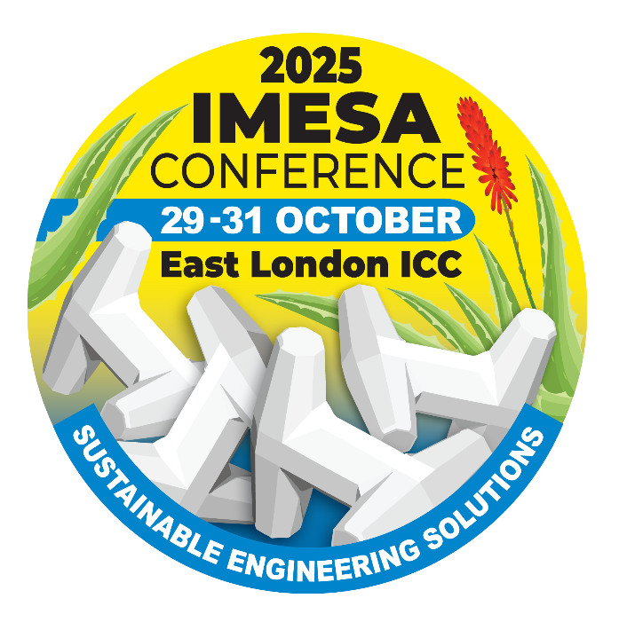

**CALL FOR**

**ABSTRACTS**

**DEADLINE FOR SUBMISSIONS**

**10 APRIL 2025**

IMESA is calling for Abstracts for consideration for the 88th IMESA Conference & Exhibition that will be held at the International Convention Centre in East London (ELICC) from 29-31 October 2025. The theme of the Conference is ***“Sustainable Engineering Solutions”***.

Main themes of the conference are focused but not limited to the following: -

* Buildings, Structures & Housing
* Ecological, Environmental & Social
* Electrical & Electronic
* Financial, Legal & Regulatory
* Transport, Roads & Stormwater
* Water & Sanitation

The title and topic of presentations will be evaluated for **innovation**, **thought**, **leadership**, **business value and interest** and **conformance to the Conference theme**. Only the best will be selected to go to the next phase.

**THE PROCESS**

Participants are required to go through a review process called the ***Call for Papers process***. All stages of the process are reviewed by a Technical Advisory Committee (TAC). The process has 3 Phases:-

|  |  |  |
| --- | --- | --- |
| **PHASE 1**  **SUBMISSION of ABSTRACTS** | **PHASE 2**  **SUBMISSION of FULL PAPER** | **PHASE 3**  **SUBMISSION of PRESENTATION** |
| **Deadline – 10 April 2025**  **AFTER REVIEW –** Participants will be notified if they will be moving to Phase 2. | Deadline communicated & applicable ONLY to successful participants of Phase 1.  **AFTER REVIEW –** Participants will be notified if they will be moving to PHASE 3. | Deadline communicated & applicable ONLY to successful participants of Phase 2.  Participants completing this Phase will be Presenting at Conference. |
| **Completed submissions to be forwarded to** **Melanie Stemmer at marketing@imesa.org.za** | | |

**IMPORTANT TO NOTE :**

All CONFIRMED Speakers / Presenters will be **fee-paying delegates** qualifying for a special reduced rate. Keep this in mind when submitting your abstract for consideration. For more information contact Melanie Stemmer on marketing@imesa.org.za or 031 266 3263.

|  |  |  |  |  |  |
| --- | --- | --- | --- | --- | --- |
|  | Photo: | | | |  |
| **NAME(S) & SURNAME:** | Click or tap here to enter text. | | | |
| **ORGANISATION:** | Click or tap here to enter text. | | | |
| **CONTACT DETAILS:** | **TEL:** | Click or tap here to enter text. | | |
| **CELL:** | Click or tap here to enter text. | | |
| **EMAIL:** | Click or tap here to enter text. | | |
| **SPEAKER RESUME**- **200 words maximum**  **\* NOTE*: Key points to include are the following:***  *Qualifications* ***/*** *Current position and past experience* ***/*** *Any seats held on various engineering boards. Any research you might have done* ***/*** *Any relevant additional information* | | | | | |
| Click or tap here to enter text. | | | | | |
| **ADDITIONAL PRESENTER - Complete ONLY if there will be an ADDITIONAL PRESENTER** | | | | | |
| **NAME(S) & SURNAME:** | Click or tap here to enter text. | | | | |
| **ORGANISATION:** | Click or tap here to enter text. | | | | |
| **CONTACT DETAILS:** | **CELL:** | Click or tap here to enter text. | **E-MAIL:** | Click or tap here to enter text. | |
| **PRESENTERS PROFILE:** | Click or tap here to enter text. | | | | |

**ORM**

|  |  |  |
| --- | --- | --- |
| **DETAILS OF SUBMISSION - Indicate what you want your abstract to be considered for** | | |
| **CATEGORY OF SUBMISSION:** |  | Buildings, Structures and Housing |
|  | Ecological, Environmental and Social |
|  | Electrical and Electronic |
|  | Financial, Legal and Regulatory |
|  | Transport, Roads and Stormwater |
|  | Water and Sanitation |
| **TITLE OF PROPOSED PRESENTATION:** | Click or tap here to enter text. | |
| **ABSTRACT - 350 to 400 words**  **\* NOTE*:*** *Take caution of word count as you could be marked down should you exceed required word limit* | | |
| Click or tap here to enter text. | | |
| **KEY PRESENTATION IMPACT POINTS:** | Click or tap here to enter text. | |

**Completed submissions IN WORD FORMAT to be forwarded to**

**Melanie Stemmer on** [marketing@imesa.org.za](mailto:marketing@imesa.org.za)